**Task 05**

Develop a C# windows form application that allows users to do all of the following:

1. [2 Points] Import a list of book's Information from an xml file (*.xml).The input file is selected from an open file dialog.

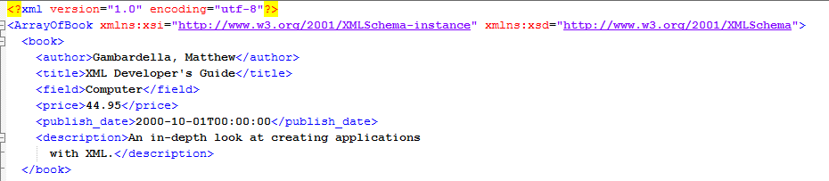

1. [2 Point] Successfully imported data are displayed on second form that contains a data grid view.
2. [3 Point] display the books with a selected range of price, the range of price [min, max] are inserted on another form.
3. [1 Point] display the books that have a computer field.
4. [1 Point] display the books published on December.
5. [1 Point] display all books.
6. [2 Point] Save the result of [3, 4 and 5] sections as XML File.